IBM – Nutrition Assistant Application Assignment –4

1. Pull an Image from docker hub and run it in docker playground.

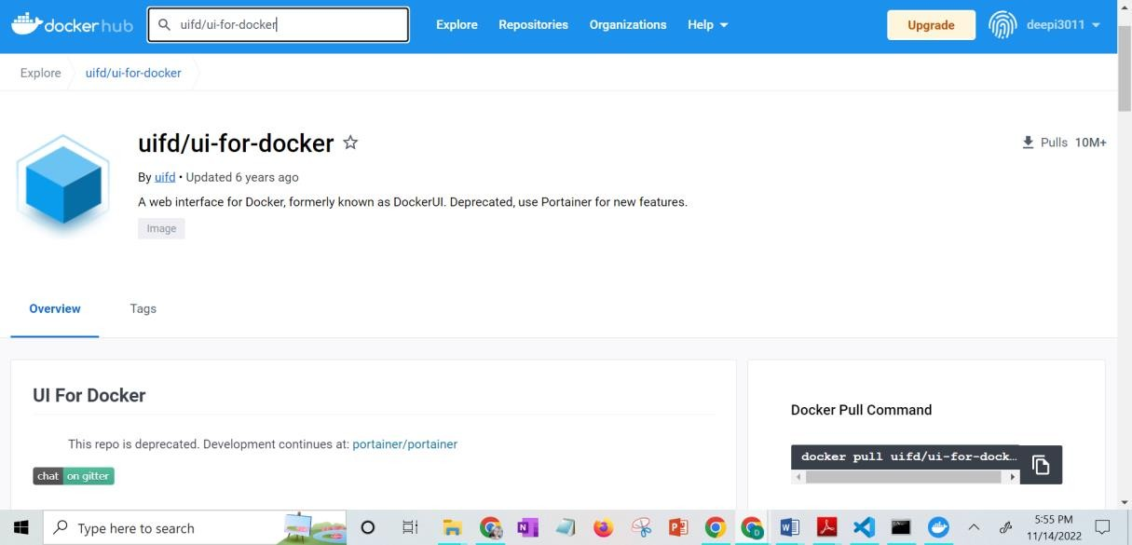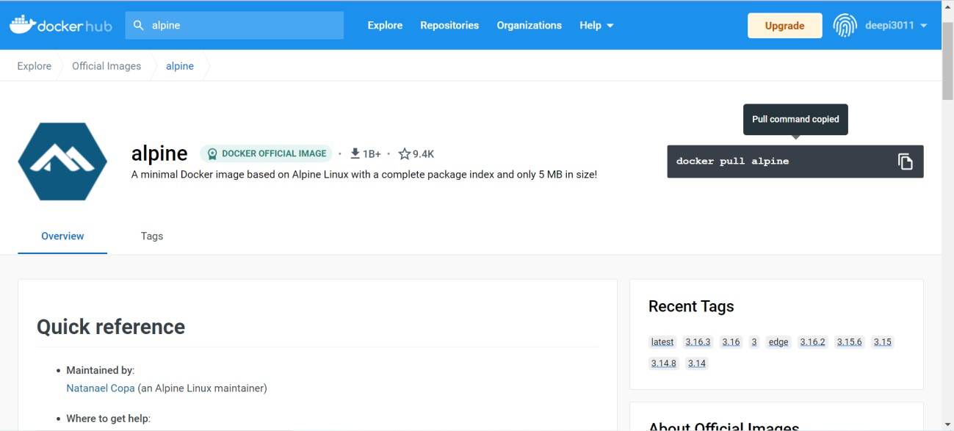

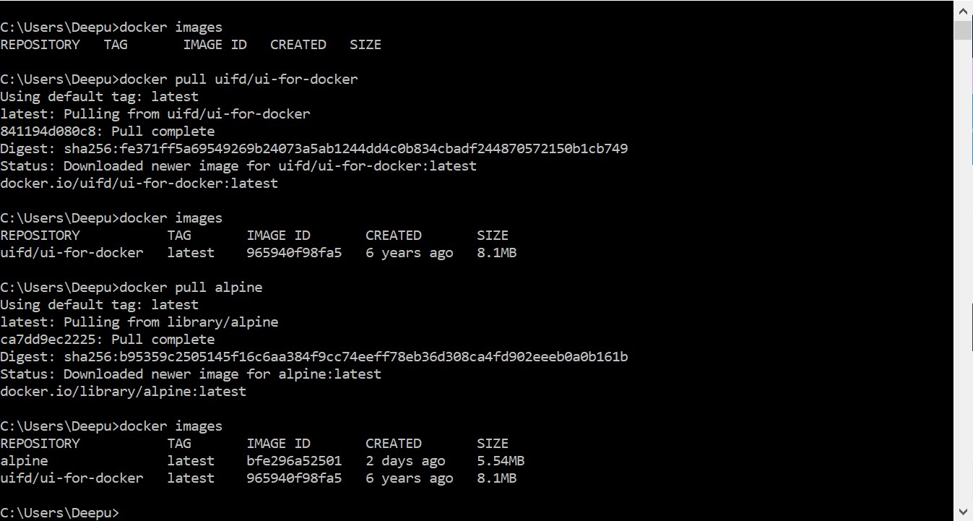

1. 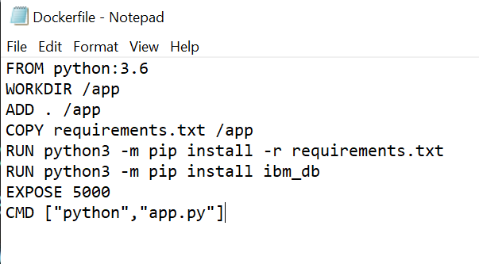Create a docker file for the jobportal application and deploy it in Docker desktop application.

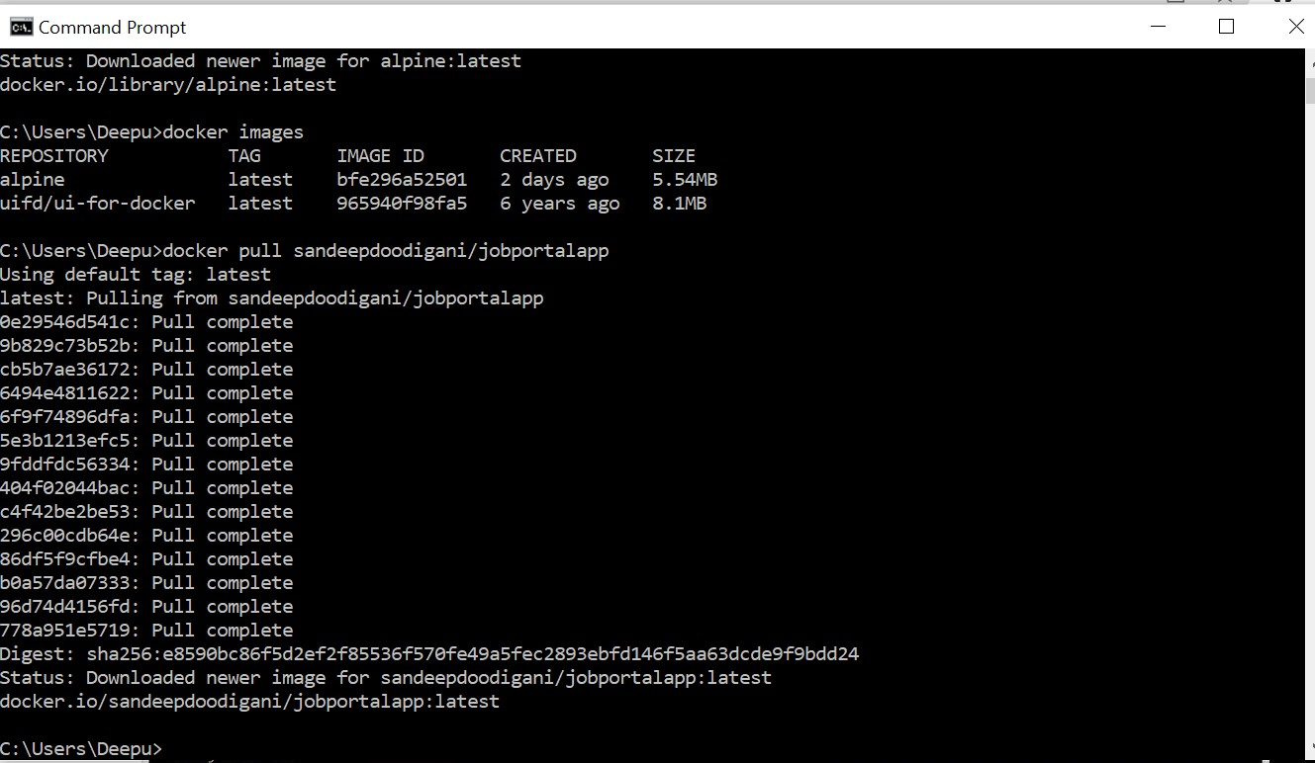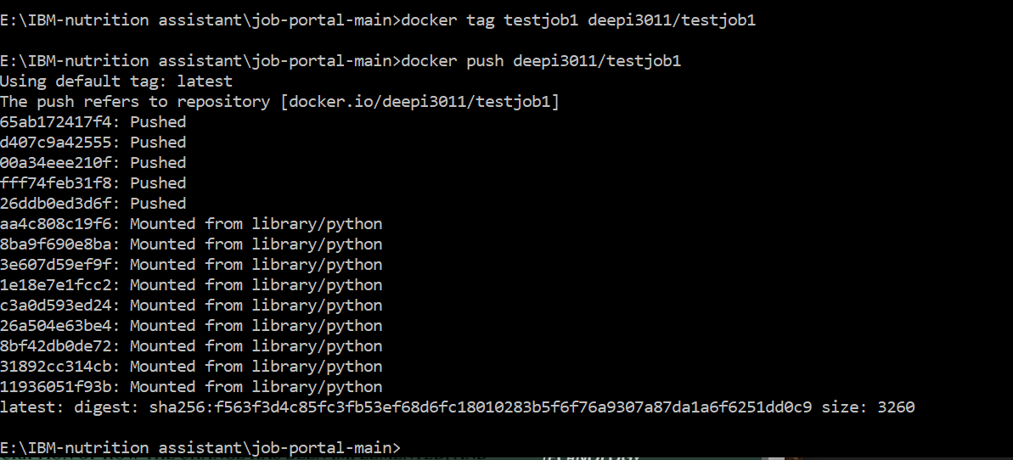

1. Create a IBM container registry and deploy helloworld app or jobportalapp.

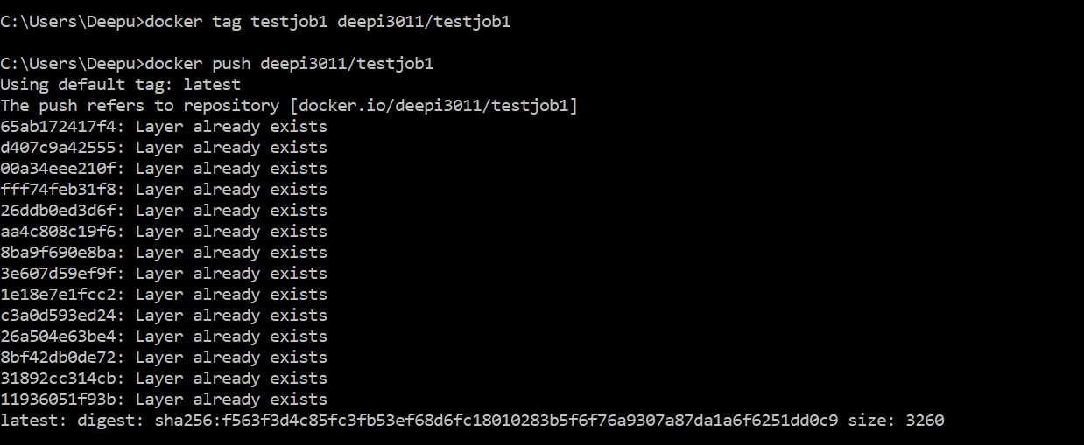

1. Create a Kubernetes cluster in IBM cloud and deploy helloworld image or job portal image and also expose the same app to run in node port.

